Introduction

Acuity24 thanks you for your recent order for a Sage Intacct subscription. Acuity24 have processed your order and your site is being provisioned by Sage. In order for work to commence on your implementation there are a couple of actions that are required of you.

Activating Sage Intacct

The dedicated ‘Admin’ user will receive a welcome email from Sage, which will look similar to below:

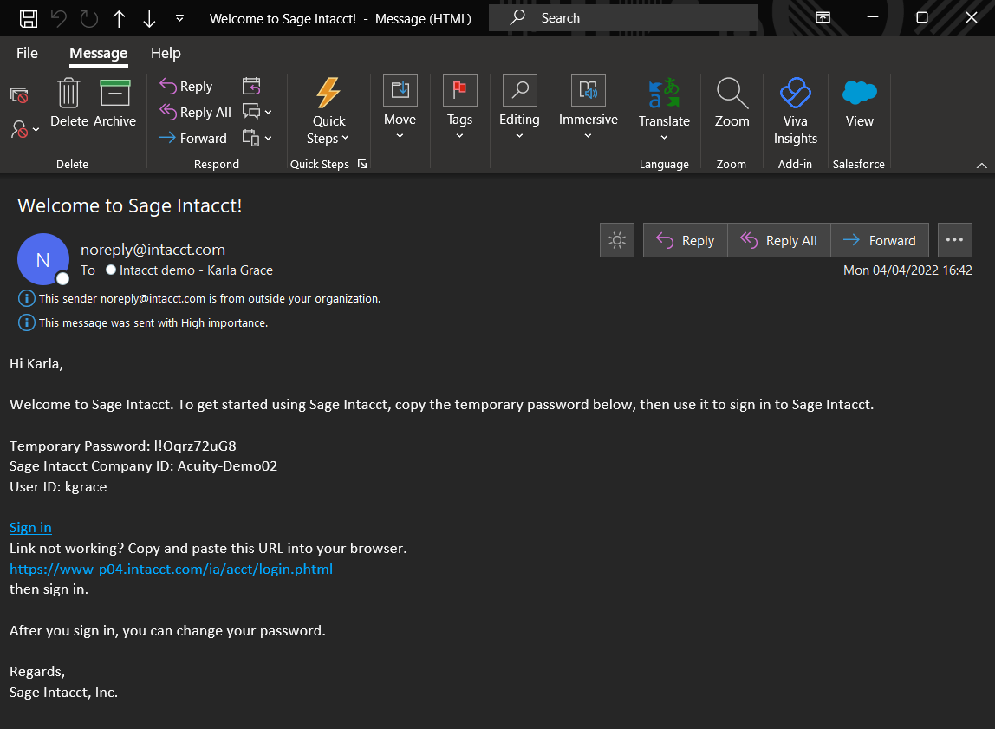

If this user hasn’t received this email, then please check the junk/spam folder, in case it is in there.
The admin user can log in using the URL ‘Sign in’ or alternately copy the link below this and pasting it into a web browser.
https://www.intacct.com/ia/acct/login.phtml?.cpaassoc=&.done=frameset.phtml
Doing either of the above actions will take you to the Sage Intacct login page where you will be presented with a screen similar to below:

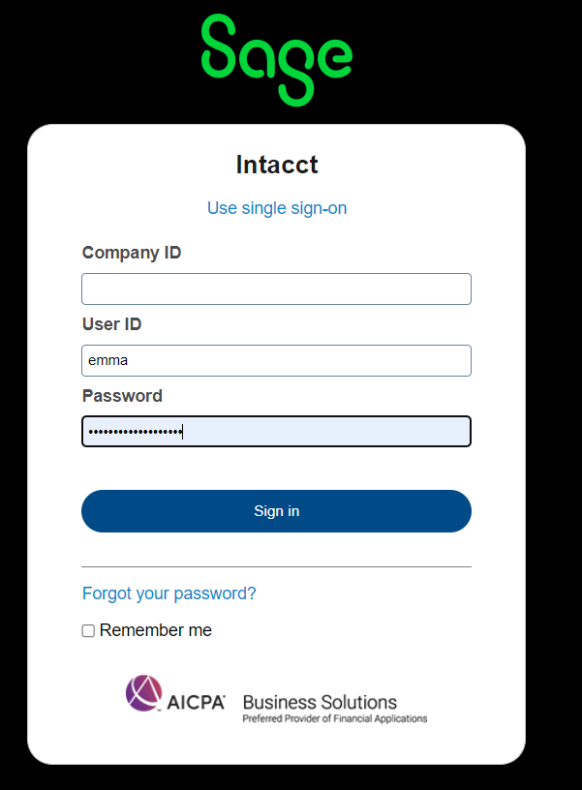

The Company ID, User ID and Password can all be found in the welcome email that you receive.
Enter these into the relevant boxes and click sign in. Each of these fields are case sensitive so please ensure that the details are entered correctly into each box.
Note – it is advisable that you bookmark this URL in your web browser for easy access to the system in future.
As noted in the email, the password provided is a temporary password and you will be instructed to create a new password before getting access to the main system. Please store this password securely as it will be used to access the system.
Once this step has been completed you will be able to access your system and you will receive another email which offers useful articles. It is not mandatory that you read these but there is helpful content included that you may wish to take advantage of.

Acuity24 Access – Part 1

After following the above process, you will be able to access your system, but Acuity24 will not. It is your responsibility to grant access ASAP so that we’re able to start building the system. Please follow the steps below to grant us access to the system.
Click ‘Applications’, from the drop down click ‘Company’, choose the ‘Admin’ tab and click ‘External Authorisations’. For reference this is highlighted below:

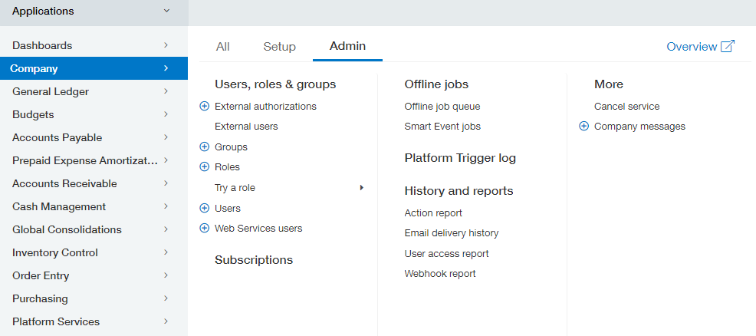

This will take you to a list view that looks similar to below:

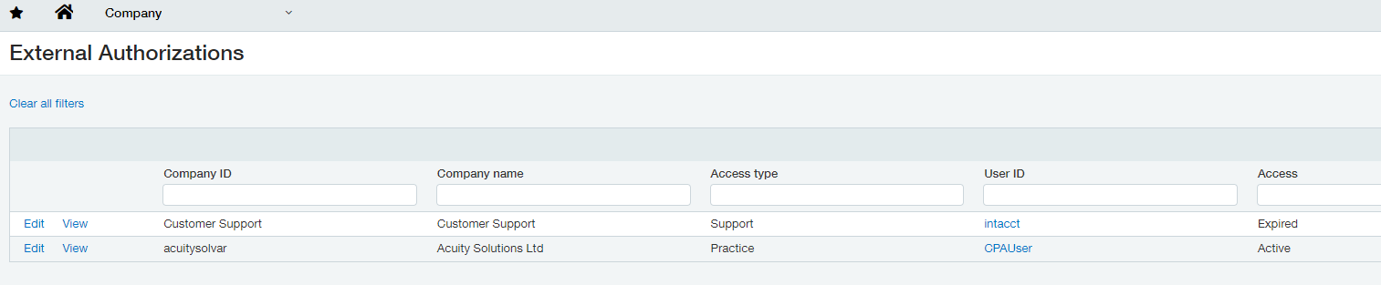

The Acuity24 user will display as ‘acuitysolvar’. Click ‘Edit’ on the left of this user and set the ‘Access’ field to ‘Enabled’ and click ‘Save’. Example shown below.
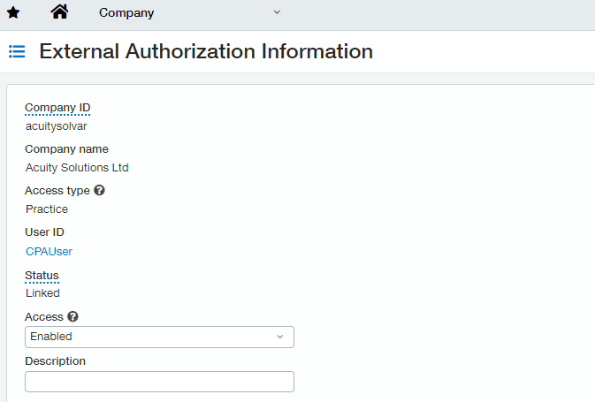

You must inform Acuity24 that you have completed this step once it has been completed as there is no automation that provides us with the detail that this step has been actioned.

Acuity24 Access – Part 2

Acuity24 must then log into the system and after this point you must grant ‘admin’ access to the user, so that we’re able to implement the system. Acuity24 will inform you that we’ve logged in, who has logged in so you’re able to perform the below step.
To do this click ‘Applications’, then ‘Company’, then the ‘Admin’ tab, and click ‘External Users’, as per below:

This will take you to another list view which will display users. Because someone from Acuity24 has already logged in, you’ll see a User ID that starts with the text ‘ExtUser|acuitysolvar|XXXX’, where XXXX is the user who has logged in.

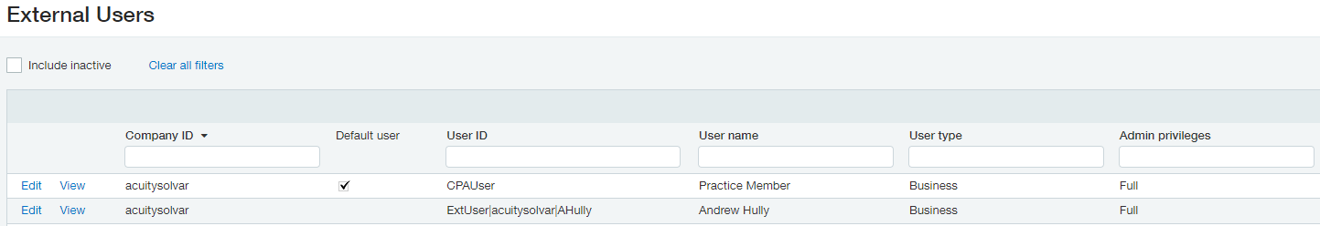

Click Edit on this user and set ‘Admin privileges’ to ‘Full’ and ensure the ‘Status’ is set to ‘Active’. This is shown below.

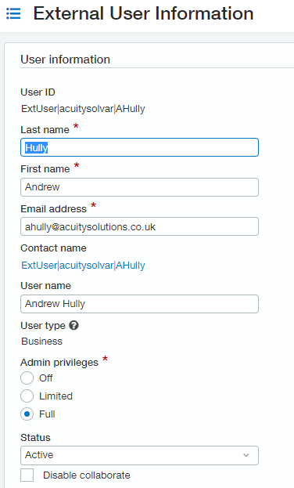

This will complete the provisioning with regards to granting your own access and allowing Acuity24 access to configure the system on your behalf.

